CS-006 Resin Infusion
Doc ID | CS-006
Title | Resin Infusion
Revision | C
Status | Draft, pending Lead signature
Effective date | 2026-08-28
Supersedes | Resin Infusion Beginner Guide (SN5), retained as intro reading; its "30 psi vacuum" figure is wrong (see §7.4)

Approvals
Role | Name | Date
Author | Simon Starbuck (drafted with Claude, SN6 Resources) | 2026-07-12
Reviewer | simon (reviewer agent) — G0 findings incorporated | 2026-07-12
Approver (Composites Lead)

Revision history
Rev | Date | Author | Description of change
A | 2026-07-12 | Claude | Initial issue. Fixes G0 review findings on the old guide: impossible vacuum number, missing resin trap, no numeric leak-down criterion
B | 2026-07-28 | Claude | Language pass: fewer em dashes for rhythm variety, no content change.
C | 2026-08-28 | Claude | Engineering pass (CS-000 Rev C conventions). Figure 1 draws the whole loop, pot to pump, with the two rules people miss when learning from over-the-shoulder: the mesh break before the outlet and the trap between bag and pump. Purpose reworded from shop slang to a statement a tech inspector could read; the Slack quote stays. No rule changed.

1. Purpose
Infusion is our main process for big parts, and in SN5 it ran without acceptance criteria: no numeric leak-down limit ("air started leaking in toward the end, hopefully it will turn out okay", #composites, 2026-05-01), an inherited guide asking people to find a physically impossible "30 psi" of vacuum, and no resin trap mentioned anywhere between bag and pump. This doc gives the numbers.

2. Scope
Resin infusion of CF/glass laminates on sealed tooling-board molds (CS-004) or flat glass/table plates, using the team's IN2/AT30 system. Wet layup: CS-007.

3. References
Ref | Document | Where
R1 | IN2 Infusion Resin TDS | 04 Datasheets/EC-TDS-IN2-Infusion-Resin.pdf
R2 | IN2 + hardener SDS | 04 Datasheets/EC-SDS-IN2-Epoxy-Infusion-Resin-and-Hardener.pdf
R3 | VB160 bagging film TDS/SDS | 04 Datasheets/EC-TDS-VB160-Vacuum-Bagging-Film.pdf, EC-SDS-VB160-Vacuum-Bagging-Film.pdf
R4 | PP180 peel ply TDS | 04 Datasheets/EC-TDS-PP180-Peel-Ply.pdf
R5 | Airtac 2 spray adhesive TDS/SDS | 04 Datasheets/airtac2imp.pdf, airtac2spray.pdf
R6 | CS-002 (stack), CS-004 (mold prep), CS-008 (resin handling) | this series
R7 | Resin Infusion Beginner Guide (SN5, background reading only) | SN5 Composites/Documentation/Resin Infusion Beginner Guide.docx

IN2/AT30 key numbers (all from R1):
Property | Value
Mix ratio | 100 : 30 resin : hardener by weight (FAST or SLOW hardener, same ratio)
Pot life @25 °C | SLOW: 120–150 min · FAST: 10–14 min
Gelation @25 °C | SLOW: 8–10 h · FAST: 2–4 h
Demould @25 °C | SLOW: 18–24 h · FAST: 6–8 h
Full mechanical properties | ≥14 days @25 °C (no oven post-cure available)
Hardener choice | SLOW for anything larger than a coupon; FAST only for small parts where you are confident of infusion time

4. Definitions
- inHg: inches of mercury, what the team's gauges read for vacuum. Full vacuum at sea level ≈ 29.9 inHg; nothing reads "30 psi of vacuum", since atmospheric pressure is only ~14.7 psi. The old guide's "30 psi" figure was a gauge-scale mix-up; if a gauge shows psi, it is reading something else.
- Drop test / leak-down: isolating the bag from the pump and watching the gauge to quantify leaks before committing resin.
- Resin trap / catch pot: sealed container between bag outlet and pump that catches over-pulled resin. Without it, the first overlong pull kills the vacuum pump.
- Pleats: folds built into the bag with tacky tape so film can reach into corners without bridging or tearing.
- Race-tracking: resin finding a fast path (usually along edges) and reaching the outlet before wetting the middle.

5. Equipment & Materials
Item | Spec / product | Source | Notes
Resin system | IN2 + AT30 SLOW (default) | Easy Composites | R1; order ≥6 weeks ahead (PP-02)
Bag film | VB160 | Easy Composites | R3
Peel ply | PP180 (or Sigmatex-supplied) | Easy Composites / Airtech | R4
Flow mesh | Green infusion mesh (or 2-in-1 mesh/peel ply) | Easy Composites / Airtech | Cover the whole part
Tacky tape | Sealant/gum tape | Airtech / General Sealants | Keep backing tab on until final placement
Spiral wrap ½" + PE tubing ½" | Feed/vacuum lines | Airtech | Watch sharp-cut ends near the bag
Resin trap | Team catch pot | RFS | Mandatory in line before the pump
Vacuum pump + gauge (inHg) | Team pump | RFS
Tack spray | Airtac 2 | Airtech | R5; light mist only
Digital scale, cups ×2, sticks | 1 g resolution | Consumables | Double-pot mixing (CS-008)
Clamp/hose clamp for feed line | — | RFS | The "clamp" in §7.5

6. Safety
Per R2: IN2 resin and amine hardener are skin/eye irritants and sensitizers.
- Gloves: nitrile at all times once resin is out; change after any contamination.
- Eyes: safety glasses when mixing and when cutting pressurized lines.
- Ventilation: mix and infuse in the ventilated shop area; IN2 vapor pressure is low but sensitization is cumulative.
- Airtac 2 (R5): extremely flammable aerosol: no sparks/heat, use in ventilated space, short bursts.
- Exotherm: a full mixed pot of IN2 left standing will overheat (CS-008 rules apply: batch sizing, transfer promptly, hot cup → outside on concrete).
- Sharp spiral-wrap ends: cut ends pierce gloves and bags alike; tape them.

7. Procedure

7.1 Prerequisites
- Stack frozen and printed on the WO (CS-002 §7.2); mold sealed + released per CS-004 with quality checks passed.
- Materials staged: resin on hand ≥ (dry fiber mass × 0.65) × 1.3 (same formula as the mix math in 7.5, rounded up since infusion consumes mesh/line resin too), all consumables cut before any resin is mixed.
- Two people minimum for any part bigger than a coupon; one experienced with infusion (unchanged team rule, R7).

7.2 Dry stack and consumables
- Workspace and mold wiped clean (IPA/microfiber). Cut cloth per the WO ply table; weigh and record total dry fiber mass on the WO.
- Lay plies per the WO, tacking with light Airtac 2 mists only where needed (heavy spray inhibits infusion).
- Peel ply over the full laminate + flange edges; flow mesh over the entire part stopping 30–50 mm short of the outlet side (the mesh break slows resin at the end and reduces race-tracking through the exit).
- Place spiral-wrap feed line along the inlet side on the flange (not on part surface unless the WO says so; print-through), and the outlet spiral toward the catch pot. Max resin travel distance inlet→outlet ≈ 0.5 m (R7 rule of thumb); larger parts need multiple feeds planned on the WO.
[ PHOTO: dry stack with mesh break visible near outlet spiral ]

7.3 Bag
- Tacky tape around the full perimeter; keep backing on until final placement. ~½ inch spacing from the part edge envelope.
- Cut VB160 oversized; add a pleat at every corner and every 300–400 mm of perimeter on curved molds.
- Fit through-bag connectors: outlet line → resin trap → pump (never bag → pump directly); inlet line → clamped shut.
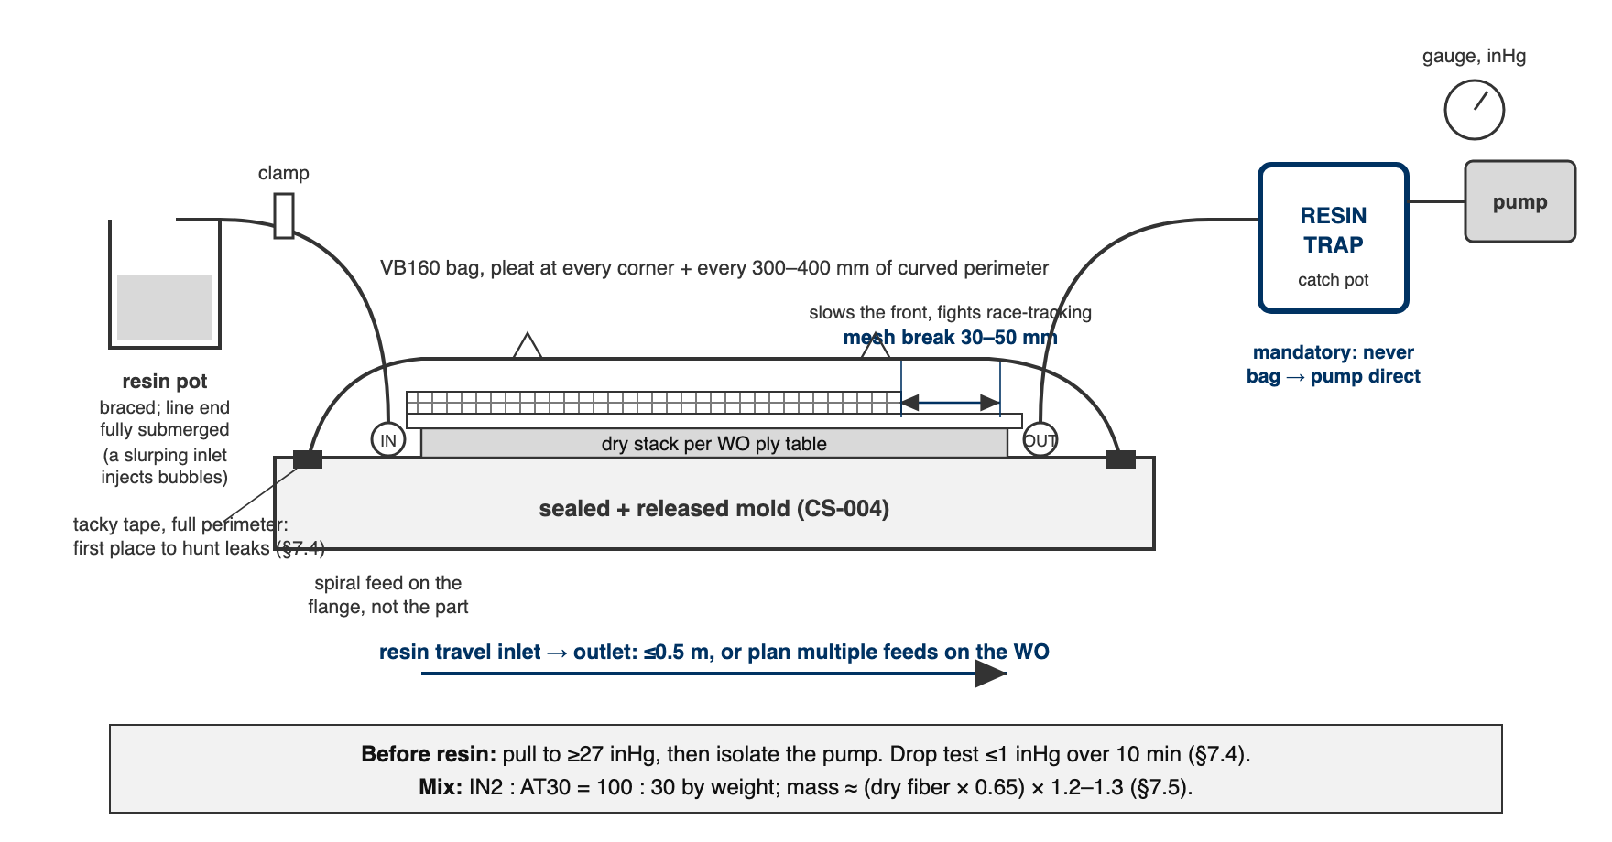
Figure 1. The full loop in section, pot to pump. The flow mesh stops 30–50 mm short of the outlet, the trap sits between bag and pump, and resin travel inlet to outlet stays at or under 0.5 m.

7.4 Pull vacuum and drop test: the blocker
- Pull vacuum. Target on the team gauge: ≥27 inHg (full vacuum is ~29.9 inHg at sea level; RFS altitude is negligible). If the gauge won't pass 25 inHg, hunt leaks now: press tacky tape seams, listen, re-seat pleats and connector bases.
- Drop test: close the valve to isolate the pump. The bag must lose ≤1 inHg over 10 minutes. Write start/end readings on the WO.
- Fail → keep hunting (seams, pleat folds, connector bases, spiral ends piercing the bag) and re-test. Do not mix resin until the drop test passes. This number is the difference between this standard and SN5's "hopefully it will turn out okay".
⚠ CAUTION: The drop test is cheap. A dry patch in a cured undertray panel is not. No pass, no resin, even at 11 pm with people waiting.

7.5 Mix and infuse
- Resin mass math: mix ≈ (dry fiber mass × 0.65) × 1.2–1.3. The 0.65 factor covers the laminate (aiming ~60:40 fiber:resin by weight); the 1.2–1.3 multiplier covers mesh/line losses. Round up; starving the infusion mid-pull is unrecoverable, and leftover mixed resin is a known cost (record actual used vs mixed on the WO to tune this).
- Mix IN2:AT30 100:30 by weight (R1) per CS-008 (double-pot, ≥2 min). SLOW hardener default: 120–150 min pot life at 25 °C.
- Brace the resin cup; submerge the inlet line end fully (a slurping inlet injects the bubbles you just vacuumed out).
- With ≥27 inHg confirmed, open the inlet clamp slowly. Watch the flow front: even progress, no race-tracking. Typical small part: 20–30 min; large: longer.
- When resin reaches the outlet spiral and the laminate is fully dark/wet: clamp the inlet. Leave the pump running through gel (SN5 practice; the "no 24/7 vacuum" optimization was never validated, revisit only with a deliberate test).
- Record on the WO: times (mix, open, full-wet, clamp), resin mixed vs used, gauge readings, anomalies with photos.
[ PHOTO: flow front mid-infusion, even progress across the part ]

7.6 Cure and demould
- Demould at 18–24 h @25 °C for SLOW (6–8 h FAST) per R1; colder shop = longer, be patient (gel ≠ cured).
- Full mechanical properties take ≥14 days (R1); schedule trimming freely, but no structural/fit loading before then where avoidable.
- Demould, label part per CS-001, photograph, weigh, record in WO qualityChecks; hand to CS-009 for trim.

7.7 Troubleshooting (the section the old guide promised and never delivered)
Symptom | Likely cause | Do
Gauge won't reach 25 inHg | Perimeter leak, connector base, pleat fold | Press seams, re-seat; soapy-water on suspect spots
Passes to 27 then creeps down | Micro-leak: spiral end or bag puncture | Patch with tacky tape square; re-drop-test
Resin racing along one edge | Race-tracking channel at the flange | Clamp inlet briefly; rely on mesh break; note for next mold (tape a dam)
Dry patch far from inlet | Mesh didn't cover; distance >0.5 m | If still wet: emergency second feed. Cured: record as defect, assess vs qualityChecks
White/foamy resin at inlet | Bubbles from slurping cup | Re-submerge line; bubbles usually trap in mesh, note location
Resin in the trap filling fast | Over-pull past full wet | Clamp inlet earlier next time; trap is doing its job; empty before it nears the pump port

8. Quality checks / acceptance criteria
Check | Target | Method | Record where
Vacuum before resin | ≥27 inHg | Gauge | WO
Drop test | ≤1 inHg / 10 min | Timed gauge readings | WO (start/end values)
Full wet-out | No dry patches visible through bag | Visual at clamp time + after demould | WO qualityChecks + photos
Resin usage | Mixed vs used recorded | Scale | WO
Part mass | Per WO target ±10% (default) | Scale | WO qualityChecks

9. Records
WO records: drop-test numbers, times, batch masses, hardener speed, gauge log, photos (dry stack, bagged, flow front, demolded), deviations. These records are how the next season learns what 0.5 m really means on our parts.

